RAJGAD DNYANPEET’S

ANANTRAO THOPATE COLLEGE,BHOR

PROJECT REPORT ON

“MILK HOUSE MANAGEMENT”

SUBMITTED BY

1.PAWAR SHUBHAM SATISH

2.JADHAV KUNAL KISAN

TO

UNIVERSITY OF PUNE

FOR THE ACADMIC YEAR 2017-2018

PROJECT GUIDE: PROF.DESHMUKH SIR.

***ACKNOWLEDGEMENT…***

This Project is an Application Knowledge Based **understanding with real world approach to it. It gives me great pleasure to my project “Milk House Management System”.**

we are happy to acknowledgment valuable guidance, inspiration & help of our project guide Prof**. Prashant Deshmukh Sir** & without whose valuable co-ordination & spirit , the present project would have been incomplete.

We Express our sense of gratitude to them for suggestion give to us from time to time while preparing our project Work.

We are Thankful our **All Teacher staff** and **our H.O.D Prof. Ranade Sir.**

**We Are Extremely Grateful To Everyone who Helped Us Throughput In Making Of This Project**

***Thanking You…!***

**Shubham S. Pawar**

**Kunal K. Jadhav**

°°°PROJECT PROFILE°°°

|  |  |
| --- | --- |
| Project Definition: | Milk House Management System |
| Objective | To Provide Basic Facility Manage Organization Schedule and work |
| Front End | JAVA |
| Back End | POSTGRESQL |
| Other tools | MS Office 2010 |
| Operating Environment | Window 10 Any Compatible OS |
| Project Internal Guide | Prof. Prashant Deshmukh |
| Developed By | Shubham Pawar, Kunal Jadhav |

°°INTRODUCTION TO SYSTEM°°

Manual System is bulky, time consuming and creates bulky database as stored on papers.

The Existing system is god for nature but we focus on drawbacks of that system, also going to reduce that all drawbacks of such system for the Efficiency, reliability of that system.

This system provides us stored, buyed, purchased data about product in collective report format.

The purpose of system is computerized and advance language. Therefore it give facility of present system.

In this system we have to enter username and password correctly for access all about milk house data information.

Today computer software is the important technology on world stage.

This project created by two group member under consideration of technical, economical and operational feasibility.

Thus promising the satisfying result…!!

***°°°***EXISTING SYSTEM**°°°**

• When we Analysis the Manage about this firm then we face

that they working with manual. And we all know that the

manual system has many disadvantages. Some are mentioned

below…

– The manual system requires more time for processing.

– It requires more critical work.

– The manual system is more error prone.

– Difficult to maintain.

– Manual system is costly.

– Immediate response to the queries is difficult and time consuming.

– More men power needed.

– manual system show of the particular place

°°°NEED OF NEW SYSTEM°°°

• New system is required because of some advantage of new system are as below…

– The new system required less time for completion of any work.

– New system is decreasing the chances of error.

– New system should work smoothly and very fast.

– New system saving time and manpower.

– The system is user friendly and any one having computer knowledge

can handle it easily.

– Suitability for computerized data entry. Maintaining Dairy information,

Staff information & Customer information, Milk Rate Information.

°°°SCOPE OF SYSTEM°°°

1.MAINTAINANCE:

Maintaining the information about all activities.

2.SECURITY:

Providing the security for login for system authenticate authorized access.

This system is made with the owner point of view. Of managing all activities.

This system developed in java where user can easily manage their product with hand-held device.

This system helps to manage whole milk shops and stores.

**°°FESIBILITY STUDY°°**

1.ECONOMICAL FESIBILITY **:**

No additional resources are needed for the development of this system.

The cost incurred during the development o this system is negligible considering the wide and cheap availability of the s/w and h/w products used in Its development.

Hence this software is economical feasible.

2.TECHNICAL FEASIBILITY:

The proposed system required following:

A standalone pc/laptop also minimum 160GB harddisk (with at least 500MB free disk space)

A minimum of64GB RAM.

Windows/linux operting system.

Since all the above mentioned componants are easily available the system is technically feasible.

3.OPRATIONAL FEASIBILITY:

This system is simple to understand, hence the user can after being familier with the componants will be able to operate the software effectively.

More over the system is flexible and the developer are skilled enough to any modification as per requirments.

Thus above system is operationaly feasible system .

°°°PRILMINARY INVESTIGATION°°°

An important outcome of preliminary investigation is the determination that system is feasible or not.

In the conduct of feasibility study, there are major distinct and interrelated areas were taken into concideration.

They are above written already.

°°°REQUIRMENT ANALYSIS °°°

Analysis of requirments includes studying the existing system and collecting data.

During analysis ,data are collected on available FACT FINDING TECHNIQUES…

Processor 1.60GHz

RAM 512 MB

Hard Disk 40 GB

Operating System Window XP or any Compatible

Operating System

°°°FLOW CHART°°°



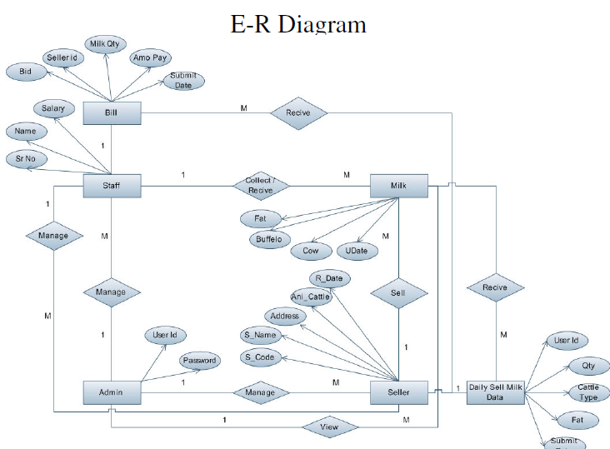

°°°CONTEXT LEVEL DFD°°°



°°°USE CASE DIAGRAM°°°



°°°ACTIVITY DIAGRAM°°°



°°°CLASS DIAGRAM°°°



°°SEQUENCE DIAGRAM°°°



°°°DATA DICTIONARY°°°

1. Seller Registration:

|  |  |  |
| --- | --- | --- |
| FIELD NAME | DATATYPE | DISCRIPTION |
| Seller Id | integer | Seller identity number |
| password | Varchar(10) | Seller password |
| Name | Varchar(20) | Seller name |
| City | Varchar(25) | Seller address |
| Animal cattel | Varchar(10) | Seller animal |
| Reg. Date | Varchar(15) | Restration date |

2Milk Submition :

|  |  |  |
| --- | --- | --- |
| Name | datatype | Discription |
| Id | Integer | Customer id |
| Fat | Integer | Quality of milk |
| Liter | Double | Quantity of milk |
| Rupees | Double | Total rupees |

3.MILK_SELL :

|  |  |  |
| --- | --- | --- |
| Field Name | Datatype | Discription |
| Date | Varchar(15) | Date of selling day |
| C_no | Integer | Customer number |
| Liter | Double | Quantity |
| Rate | Double | Milk rate |
| Rupees | Double | Total rupees |

4.PRODUCT SELL:

|  |  |  |
| --- | --- | --- |
| Field name | Datatype | Description |
| Item | Varchar(20) | Name of item you have |
| Quantity | Integer | How much item you have |
| Rate | Integer | Rate of that item |
| Total | Integer | Total rupees |

°°Login screen :°°

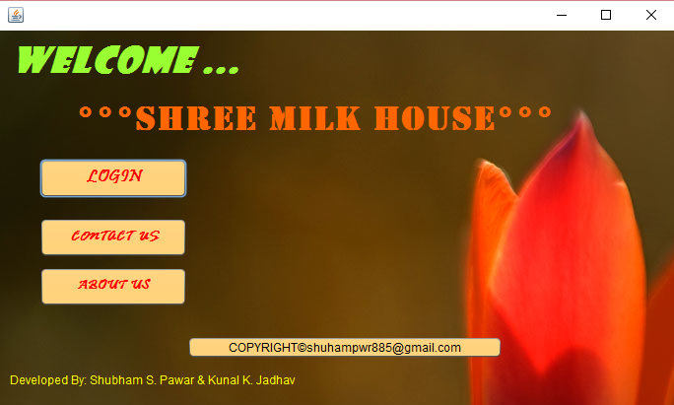

**AFTER CLICKING LOGIN BUTTON:** 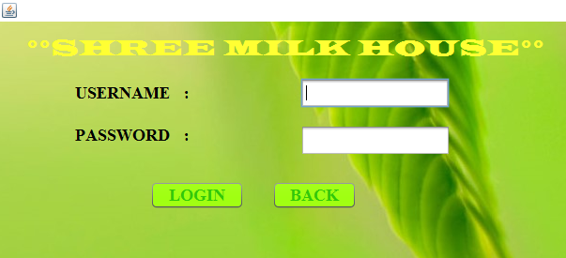

After entering Wrong username or password:

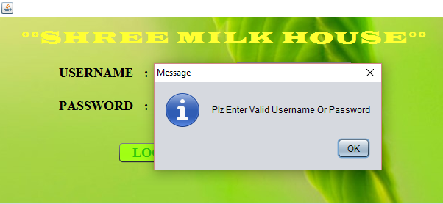

After Entering Correct username and password:

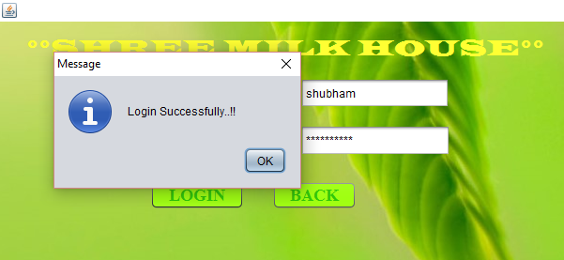

After login successfully 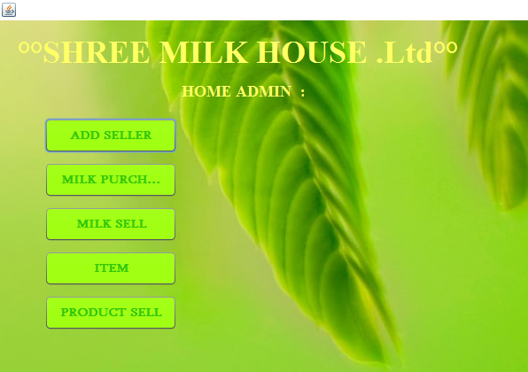

Clicking on ADD SELLER Button 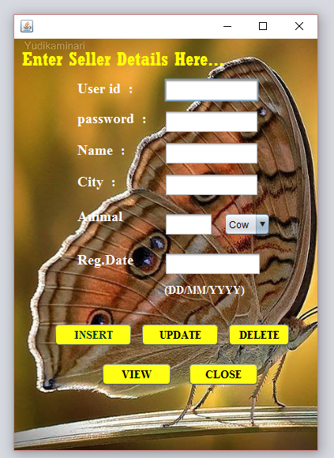

Insert a seller if something wrong.!! frttgujjjfr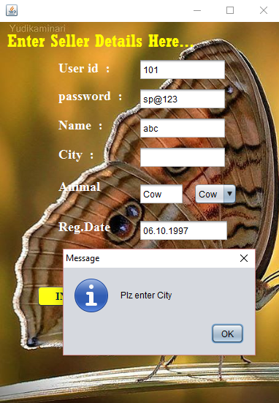

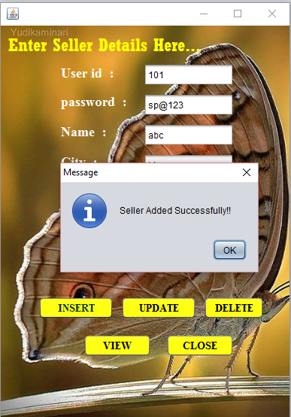

Click on update Button

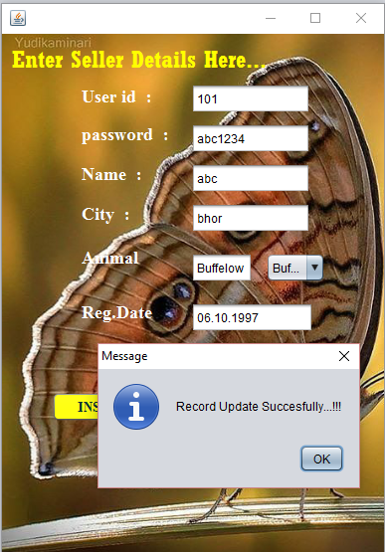

Click on VIEW BUTTON

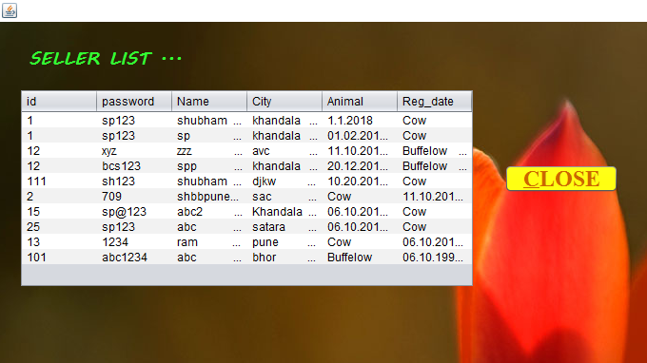

Click on MILK_PURCHASE button:

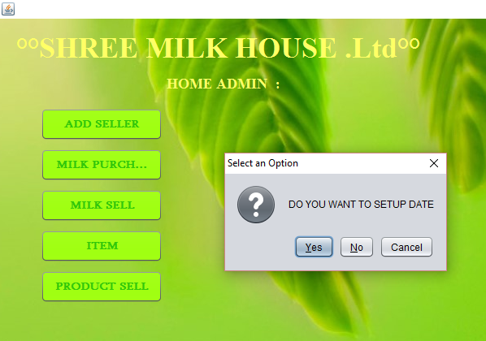

Then set Date

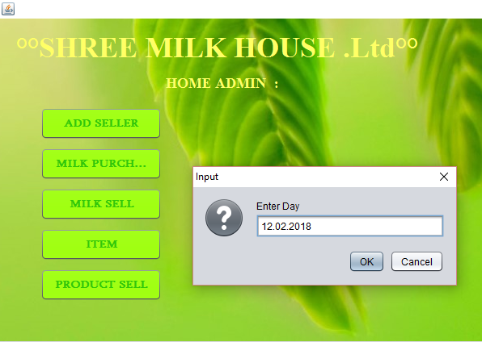

Then set milk rate 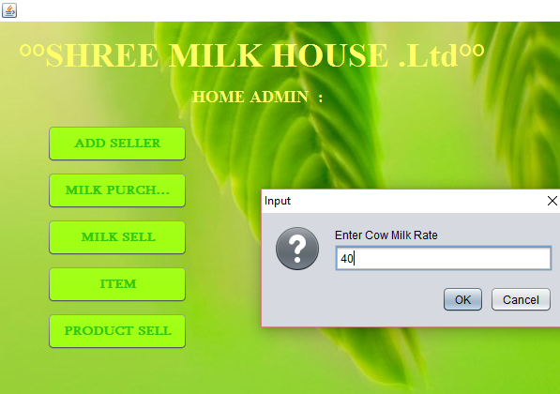

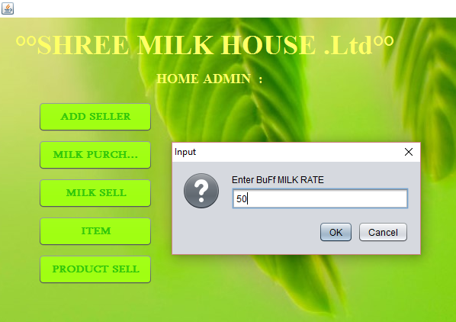

After settting up DATE & RATE of milk

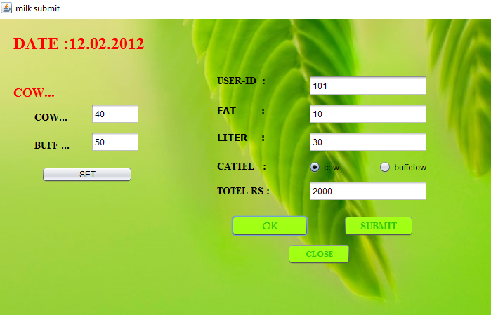

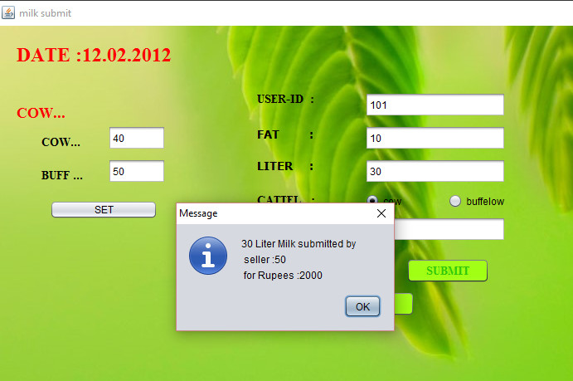

After clicking MILK SELL BUTTON:

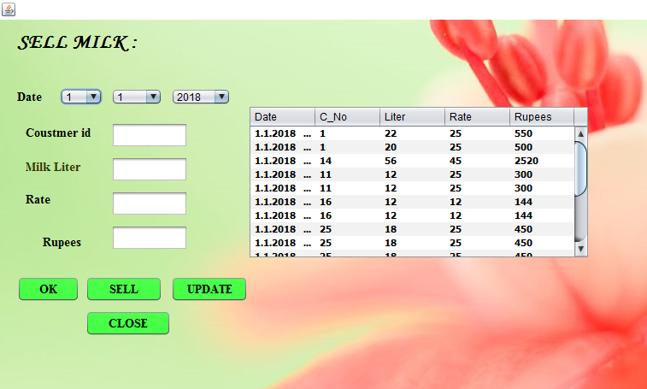

SELL MILK FOR CUSTOMER

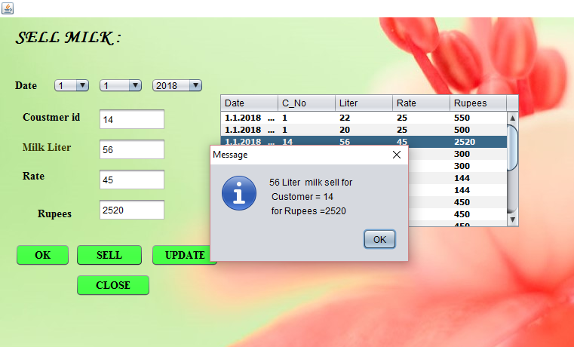 WANT TO UPDATE SELL RECORD

CLICK ON UPDATE BUTTON

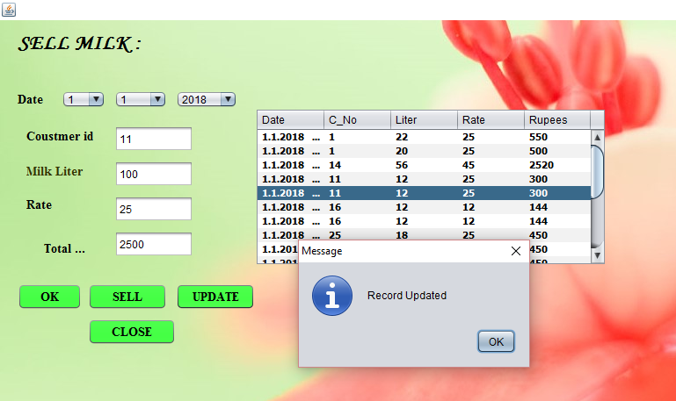

Click on PRODUCT_SELL :

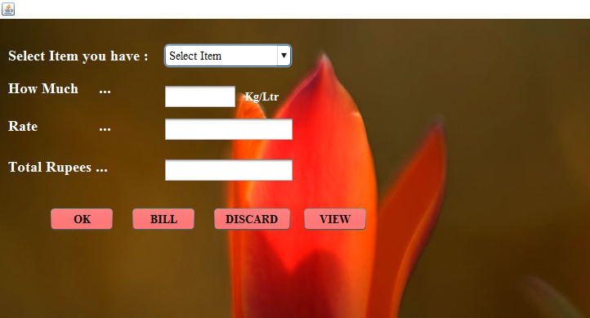

SELECT ITEM THAT CUSTOMER WANT..!!

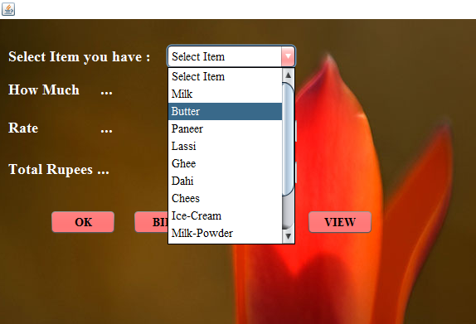

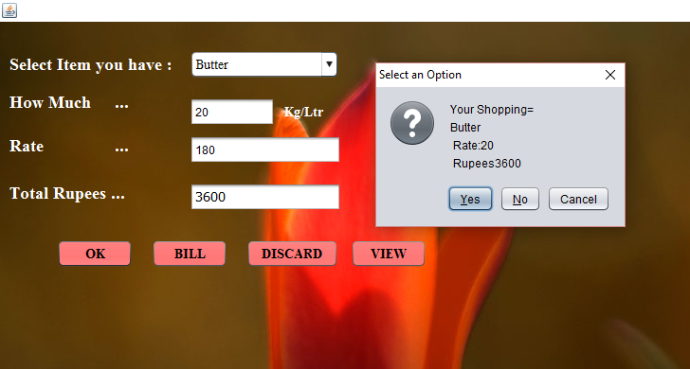

want to view total record of selling product

click on VIEW Button

